

DEVOPS FOR CLOUD COMPUTING
Assignment

Name:
Tehreem Mirza

Registeration No:
FA22-BSE-088

Section:
BSE-8B

Submitted To:
Sir Muhammad Ibrahim

Ansible Installation on WSL Ubuntu:
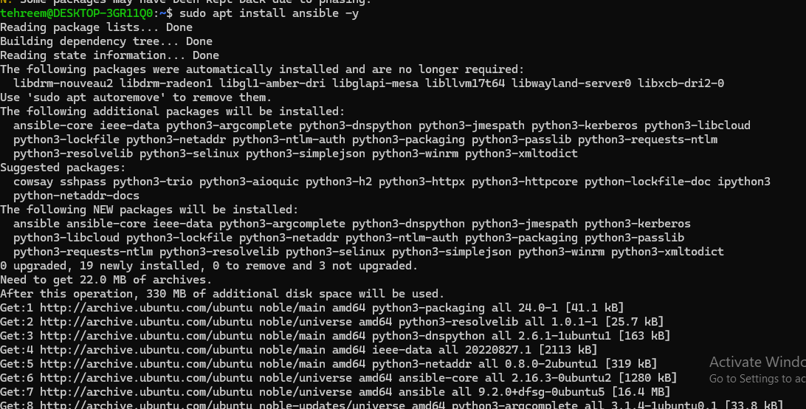
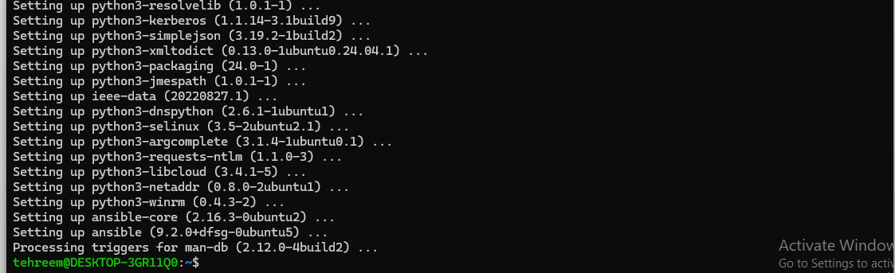

Creating inventory file in ansible:
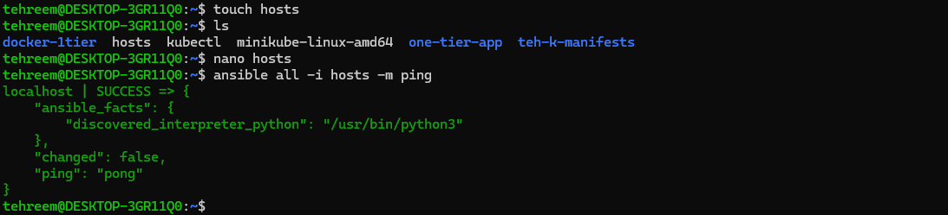
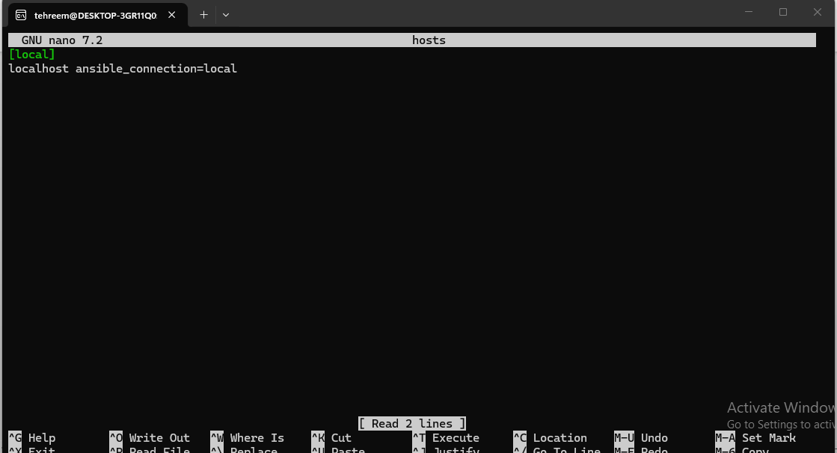

Creating playbook in ansible:
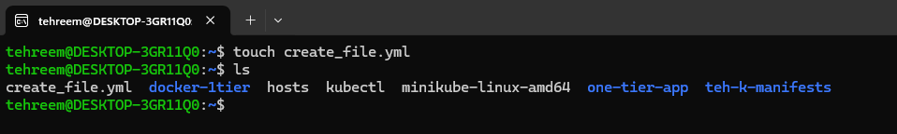
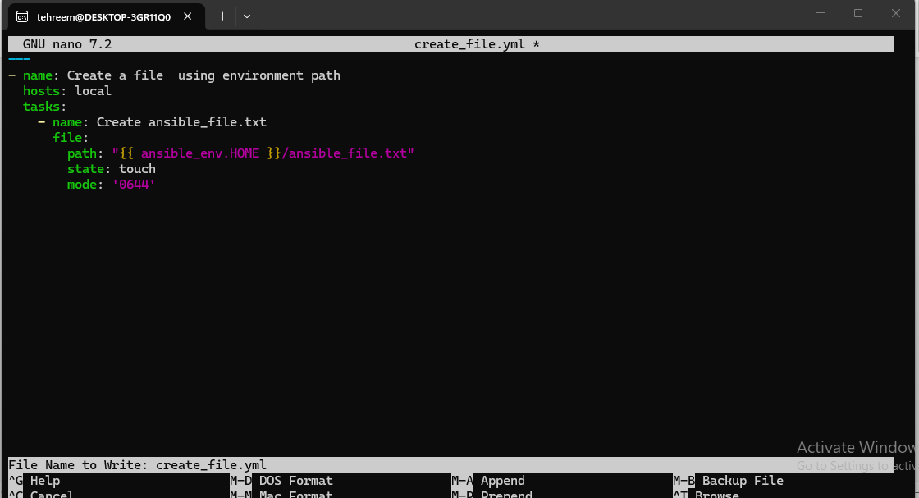
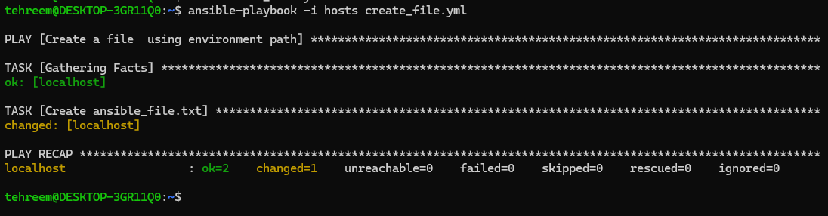

Deploying Ansible on AWS EC2:
Creating an instance:

Connecting AWS to in order to access and use it through WSL :
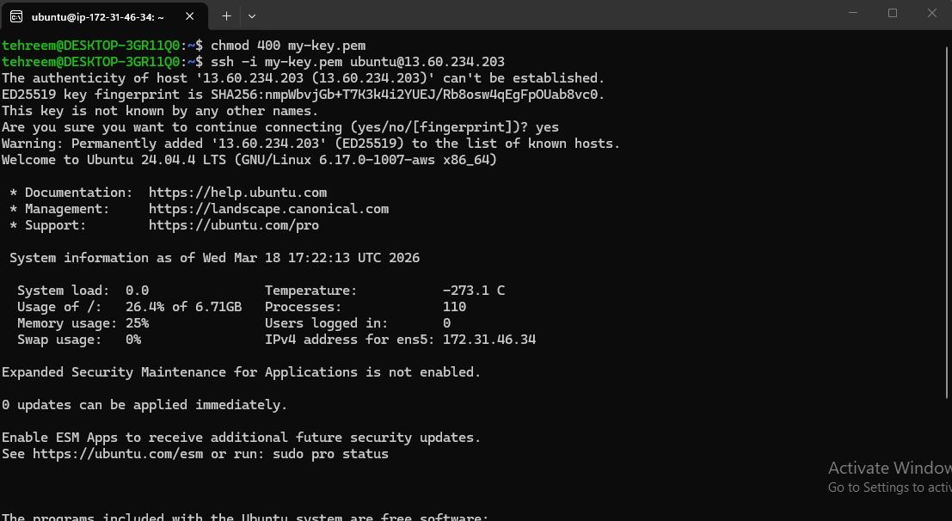
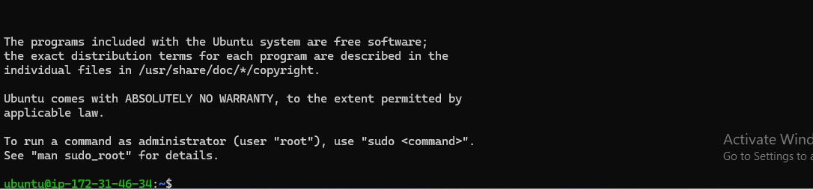

Connecting ansible to remote machine:
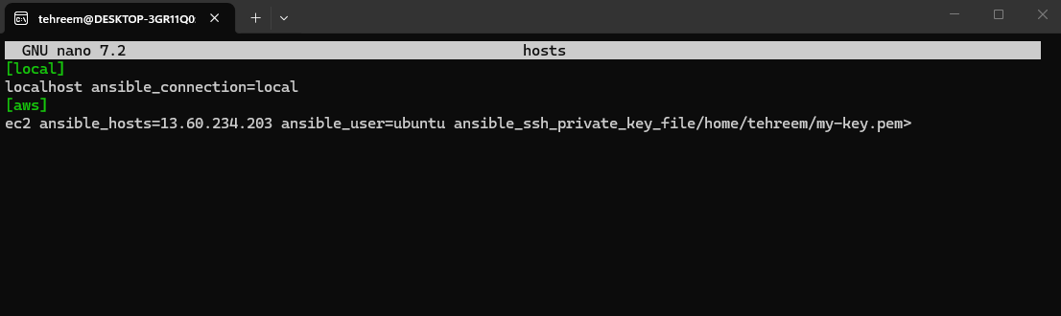

- Create an inventory file name host to list all servers that Ansible will manage and add server details through command nano host (inventory file name)
- Verify that Ansible can connect to your server

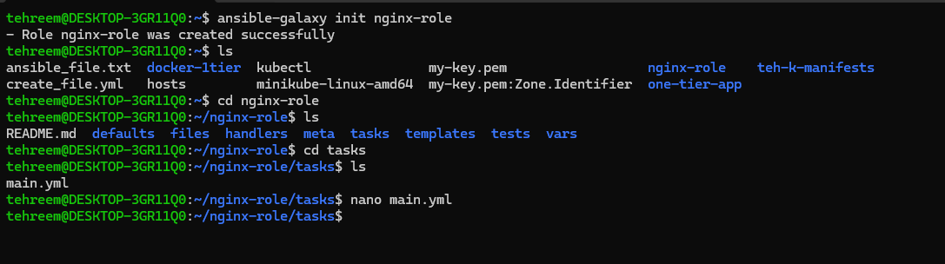

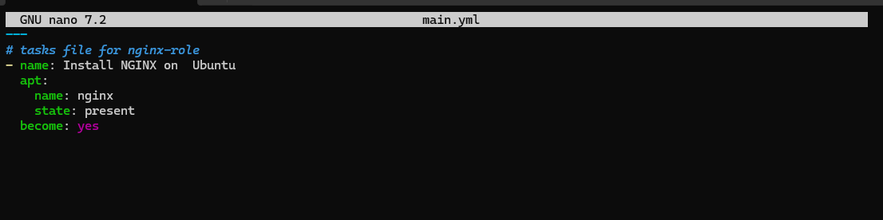

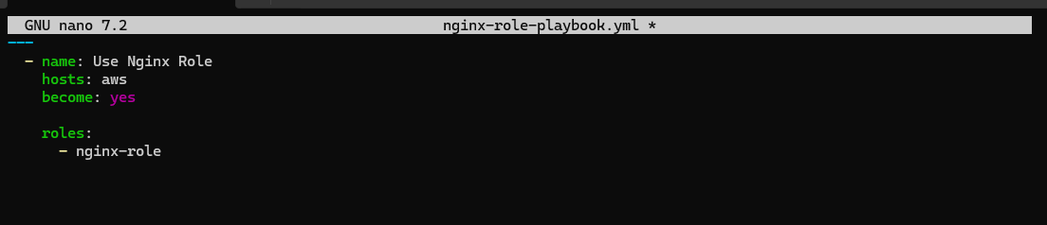

- Create Ansible Playbook file (install_nginx.yml) that Define tasks for Nginx installation and updated package cache.
- Run the Playbook to Execute the installation tasks on remote machine(s)
- Verify Installation on remote machine



